*Daniel Swain*

*PropertyDome | Perth, Western Australia*

*Project Plan*

Real Estate Website

Table of Contents

Revision History 3

Scope 4

Deliverables 4

Functional Requirements 4

Final Design Decision 5

Completion Criteria 6

Objective 7

Constraints/Assumptions/Risks 7

Milestones 8

Approach 8

Issue/Change Request Management 8

Communication Management 8

Stakeholders 9

Work Breakdown 9

Detailed Work Breakdown 9

## Revision History

Rev 0: 23/02/2016.

* Initial version.

Rev 1: 21/04/2016.

* Updated milestone dates to reflect current status of the project.
  + Client approval date changed to 6th of April
  + Development completion date changed to 25th of May
  + Testing completion date changed to 7th of June
  + No change to delivery date (9th of June)
* Updated risks to include the following:
  + Little access to the client to discuss/get approval for decisions, leading to potential abortive work or work being prioritised that the client does not need at that time.
  + Increased chances of bugs slipping through due to testing time being scaled back due to the delays in getting design/development approval eating into development time.
* Updated client stakeholder to Nichola Kerr who is acting as the intermediary between groups and the client.

Revised: 10/06/2016.

* Updated functional requirements to include client feedback on designs
  + Website to be built to the approved design criteria received from the client on the 6th of April.
* Updated milestones to reflect their completion status at the end of the project
  + All revised milestone dates were met except for the development milestone, which slipped from the 25th of May to the 1st of June.
* Updated approach to remove references to Web24 server for development as the site was developed using student servers (both for MySQL databases and the Rails server). Also removed reference to Foundation as it was decided that Semantic-UI could be used for all pages (rather than Semantic-UI for user pages and Foundation for Admin pages).
* Added section “Final Design Decision” detailing the final design decision as handed down by the client on the 6th of April. This includes screenshots of the final site mockups/wireframes of various pages.
* Added final contents page and cover page.

## Scope

The client brief is to design, build and deploy a real estate website where users can search for and upload houses for sale using a set list of criteria as detailed in the functional requirements. House posts are to be valid for 8 weeks, after which they expire and are flagged for removal from the database by the admin. User uploads allow for 10 images in a free tier, with extra features unlocked by payments which are outside of our scope. User uploads are held in staging for review by admin prior to being searchable on the site.

## Deliverables

By the completion time of the project the team will have delivered to the client the following things:

* Database - The database which will hold all relevant data for the website to function.
* The Website/Application - The entire website developed for the client, including the backend written in Ruby, the Rails server complete with the website.
* Documentation - This will include an overview of the project layout, website functionality, an administrator user manual for the admin control panel, etc.

## Functional Requirements

The following are the functional requirements to satisfy the client scope:

* Design, construction and deployment of a site with a simple interface for people to search for houses to buy and/or upload their own content and images of their house(s) for sale to a central database using the following criteria:
  + Location: Suburb/State
  + Price: Min/Max/Range
  + Bedrooms: Min/Max/Number
  + Property type: House/ Apartment/Land/Other
  + Bathrooms: Min/Max/Number
  + Car Spaces: set number in list
  + Min Land: sqm
  + Indoor features: Air con/ Alarm / etc.
  + Outdoor features: Garage/ Swimming Pool/ Spa/ etc.
* Website to be built to the approved design criteria received from the client on the 6th of April.
* Website to work on latest version of major browsers (Chrome, Firefox, Safari, Internet Explorer) and be responsive on major mobile devices (iPhone 5, 6, 6+; Android phones with similar screen sizes 5 - 6”)
* Each house posting to last up to 8 weeks after which they are expired and flagged for removal via an admin, unless a payment is made by the user to extend the post (Payments outside of scope).
* Provision for users to upload 10 images for free. Whilst not part of our scope, extra image uploads and listing features will be able to be unlocked via additional payments by users.
* A admin interface shall be provided for staff to approve user uploads prior to their appearance on the main site.

## Final Design Decision

The final design approval decision was received by the client on the 6th of April. This included the following stipulation for the construction of the site:

* Design and flow of the site to follow the designs submitted by PropertyDome group apart from the following changes:
  + search elements to appear down the left side of the search page as per MyEstate design; and
  + single property page as per LiveIn design.
* Main header image on buy/index page shall change to an image reflecting the choice of state, i.e. Melbourne shows a Melbourne image, Western Australia shows a WA image.
* When returning to the search page from a property result view (i.e. single property page) the search criteria should be maintained and not lost via that back press.
* The like button shall save the property to the favourites.

The following images demonstrate the final design themes as stipulated by the client. Note that the final website might differ slightly from these images due to the nature of responsive web development.

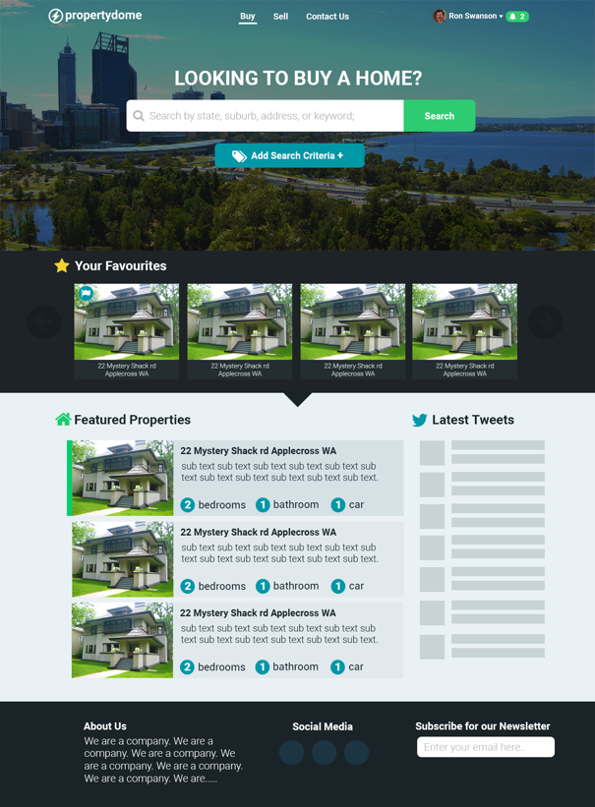 

**Landing Page (logged in) Sell page (not logged in)**.

The view on the index page when logged in. The user will see their favourited properties, as well as featured listings and company tweets.

The view on the main sell page when not logged in. The user sees advertising / testimonials from the company as to why they should sell on the site.

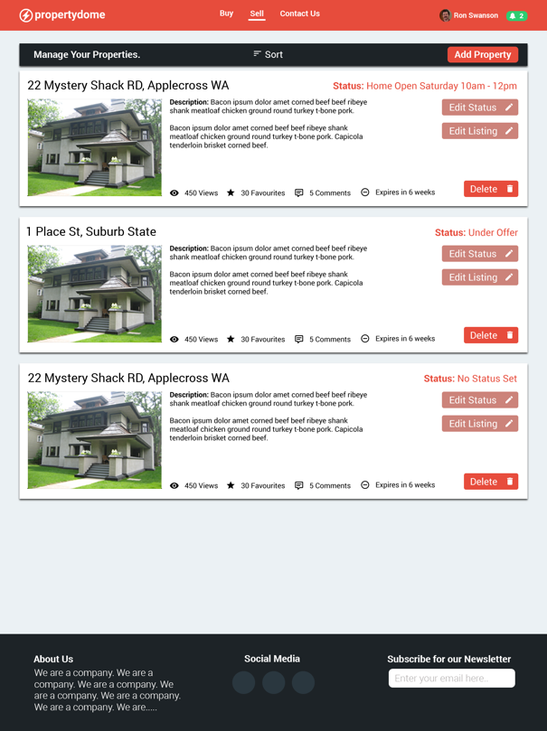 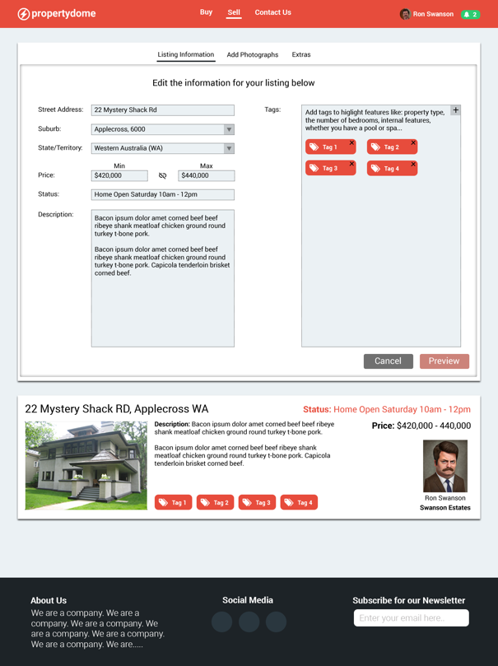

**Sell Page (Logged in showing listings) Sell Add/Edit Page**

This view shows the sell page when logged in, it lists all the user’s listings in a sortable and infinitely scrolling table.

This view shows the sell/add edit page. This is a tabbed page allowing the user to add a listing or update their listing.

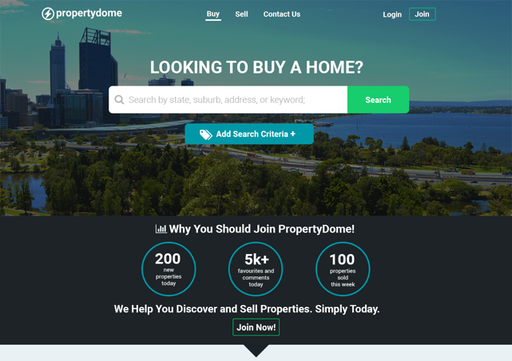 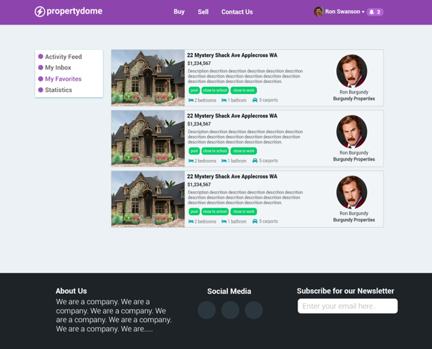

**Landing Page (not logged in) User Dashboard (showing favourites)**

This view shows the landing page as seen when not logged in. A visitor sees stat circles in place of the favourites providing useful stats as to why they should join the site.

This view shows the user’s dashboard where they can view their favourites, edit their settings and see the latest updates from the properties they have favourited.

## Completion Criteria

In order to be signed off, the Real Estate Website must meet all the functional requirements listed above as agreed upon by the client and project team, must be extensively tested for any issues, and be completed within the allocated timeframe as agreed upon and available inside this Project Plan document. The following completion criteria and testing procedures apply to the functional requirements listed above:

* New features are documented for the client to assist integration, including the structure of the project code and database.
* Site components pass minimum acceptance criteria with 85% pass rate for tests.
* No priority defects outstanding, where a priority defect is defined as a defect which crashes the site or return/performs unauthorised CRUD operations on the database.

Project success will be determined by adherence to the project specifications and objectives outlined. Deployment of the web application to the standard approved by the client and outlined within testing criteria will be acknowledged as the final stage of the successful project.

## Objective

Create a web application for the client based on the above scope and functional requirements, delivered according to the milestone schedule outlined below.

## Constraints/Assumptions/Risks

Constraints:

* Development for this project will take place at Central TAFE, this will include hosting the website on Central’s ‘Web24’ Server. Due to the server environment, the project will not be able to support anything that the current Central server cannot.
* An external MySQL database has been set up and connected to our application for the listing and user database tables.
* The project is to be completed by the 9th of June, 2016. This deadline may restrict additional features or last minute changes to the project.

Assumptions:

* The website will be developed in Ruby and deployed on Rails. In the development environment Ruby is constrained to version ‘2.2.3p173’ and Rails version ‘4.2.5’. It is assumed the client’s environment will support these versions.
* The website will not include room for 3rd party advertising.
* The website will include a simple interface for administrators to manage approval of client submissions (e.g. users posting their houses) and removing submissions.
* The website will be accessible and compatible for multiple screen sizes and different devices such as different sized monitors and mobile devices at different screen resolutions.
* The website will support all major browsers and their current/latest versions.

Risks:

* The website could be incompatible with the client’s environment due to different versions of ruby.
* Little access to the client to discuss/get approval for decisions, leading to potential abortive work or work being prioritised that the client does not need at that time.
* Increased chances of bugs slipping through due to testing time being scaled back due to the delays in getting design/development approval eating into development time.

## Milestones

The following represent the updated project milestones for 2016:

* Design completed by 30th March – Completed on time
* Client Approval completed by 6th April – Completed on time
* Development completed by 25th May – Completed by 1st of June
* Testing completed by 7th June – Completed on time
* Final Delivery completed by 9th June – Completed on time

These dates represent an initial best estimate and are subject to change due to the nature of the project. A seven-day notice will be provided to the client for approval prior to any change to these dates which will be entered into an updated project plan upon approval.

Due to the nature of Agile project management, aspects of each phase may change after these dates during other phases of the project. Any further changes outside these milestones after initial client approval shall follow the Issue/Change Request Management procedures detailed below.

## Approach

An agile scrum methodology will be utilised to complete the project goals by the given milestones above. After the initial project analysis design will progress using wireframes and prototyping.

Programming work will be completed in short ‘sprints’, providing flexibility by allowing for design and feature changes after the initial client approval period, satisfying the latest client requirements. Changes after the initial client approval shall follow the Issue/Change Request Management procedures prior to being implemented in the next ‘sprint’.

Development and testing will be undertaken using student servers prior to deployment to the client’s environment. Semantic-UI will be the front end framework used for all aspects of the sites.

## Issue/Change Request Management

To keep track of all issues and change requests, an Issue/Change Log spreadsheet will also be maintained. As team members come across issues or receive a change request, they will add an entry into the log stating what the issue/change is, when the entry was created, who will action the the issue/change and when it should be actioned by. Any change requests from the client should be sent to [tafegroup-3@googlegroups.com](mailto:tafegroup-3@googlegroups.com), the project manager will log the change request and issue a response to the client following the communication management procedure below.

For internal issue/change tracking relating to the website itself, GitHub Issues will be used. As developers find code-related issues/change requests, they will create, tag and assign a new issue.

## Communication Management

For efficient communication management roles within the team will be established. A Project Manager will be assigned and be responsible for interacting directly with the client.

For communication between the team the use of tools such as; Slack, Email, Text, Phone and face to face meetings will be employed, all of this combined will increase communication between the team. Communication with the client will be through Nichola Kerr, who will act as an intermediary for all teams.

## Stakeholders

|  |  |  |  |
| --- | --- | --- | --- |
| **Stakeholder Group** | **Stakeholder** | **Roles** | **Contact Information** |
| Central Tafe | Nichola Kerr | Project Sponsor | Nichola.Kerr@central.wa.edu.au |
| Client | Nichola Kerr | Client | As above |
| Group 3 | Daniel Swain,  Michael White,  Erdal Erkilic,  Simon Lehmann,  Tylden Horan | Project Team | Zapdome.slack.com |

## Work Breakdown

The project has been broken up into the following high level work packages:

* Documentation
* Design
* Development
* Testing

A detailed work breakdown for these work packages can be found below.

## Detailed Work Breakdown

The following table represents an initial detailed work breakdown for the project:

|  |  |  |  |
| --- | --- | --- | --- |
| **Documentation** | **Design** | **Development** | **Testing** |
| Scope/ Functional Requirements | WireFrame | Coding Structure | Test Functionality |
| Deliverables | Animations | Programming | Fix Bugs |
| Completion Criteria |  | Functional Requirements |  |
| Objectives |  | Admin Pages |  |
| Constraints/Assumptions/Risk |  |  |  |
| Stakeholders |  |  |  |
| Communication Management |  |  |  |
| Issue/Change Request Management |  |  |  |
| Milestones |  |  |  |